**Sitemaps and Wireframing**

Sitemaps and wireframes are important planning devices to set out the design of your website. It’s useful to get an idea of both scope and technical features that needs to be implemented. It’s important to follow this document while setting up your sitemap and wireframes.

Sitemap

A sitemap is an aid for laying out the different pages on your website as well as how they are linked together. This helps with having a quick visual representation of how many pages you need to create as well as how they are connected.

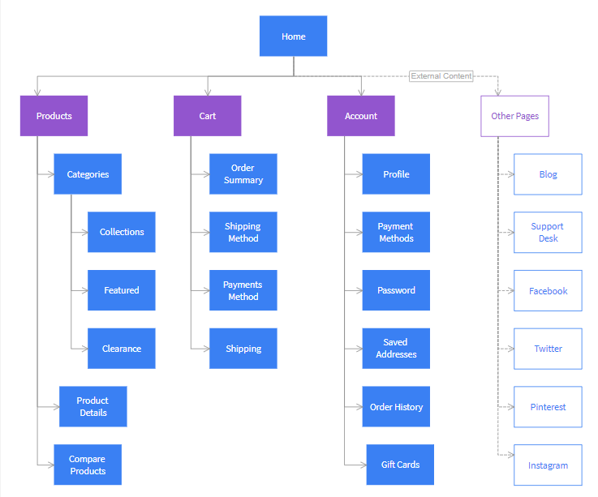

Above is an example of an E-commerce sitemap. There are several online tools you could use to set it up or you could use a digital drawer or even a pen and paper.

Here is an example of an online sitemap tool: https://www.gloomaps.com/

As you can see it uses blocks with the name of the page linked with lines to visually display how to navigate there.

Wireframe

A wireframe is another visual tool for planning. This sets up a visual diagram of a rough plan of each page. The design does not include colours or visual design but rather the raw layout of a web page. This would include every single section like buttons, text, etc. This can be done with online tools or this can be done with a digital drawer or a pen and paper (and some presstick).

Here is an online wireframe tool to use for free: https://app.lucidchart.com/ This has a free option and allows you to set up flow diagrams as well as other charts. You are also welcome to use any tool you find or a pen and paper too.

Below are examples of wireframes.

Some of the common applications that you are expected to develop for your final project includes (but not limited to) **e-commerce such as B2B**, **customer relationship management**, **ticketing system, social media platform**, **inventory** control systems, blog etc. A B2B is a situation where one business makes a commercial transaction with another. B2B companies are supportive enterprises that offer the things other businesses need to operate and grow. Payroll processors and industrial suppliers are a couple examples. Try give your own examples.

Please read more on these projects. Find examples and attempt to create sitemaps or wireframes for each of the chosen project.